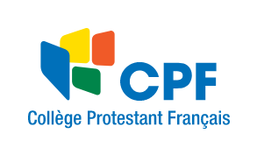
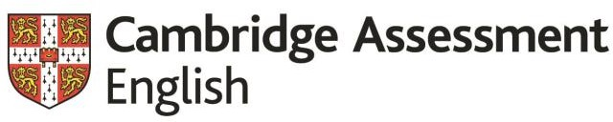

University of Cambridge Local Examinations Syndicate (UCLES) Cambridge English Language Assessment (CELA/ESOL)

Please attach your photo here.

Registration Form
Please tick which exam and session you would like to register for:

YOUNG LEARNERS STARTERS | 100 dollars
YOUNG LEARNERS MOVERS | 110 dollars
YOUNG LEARNERS FLYERS | 120 dollars
KET | 140 dollars

First Name*: Family Name:

Date of Birth: (dd/mm/yy)

Address:

E-mail:

Home Tel: ID Number: Mobile: Name of School
Date: Signature:

- YOU NEED A COPY OF YOUR PASSPORT/ID AND A PHOTOGRAPH
Office use only

Exam fee: Date of payment: Receipt No./ECR No.: _ Administrator’s initial: WBS:

The United Kingdom’s international organisation for educational opportunities and cultural relations. We are registered in England as a charity.

